BOSST-GARREN TALDEA

**Authors: Abde, Jon and Beñat**

**Date: 5/3/2021**

INDEX

1. PROJECT CONTEXT 5

2. APPLICATION ANALISYS 5

a) WEB 5

b) Java application 6

3. APPLICATION DESIGN 6

A) Use case diagrams 6

B) Activity diagrams 8

WEB 8

JAVA 9

C) Class diagram 9

4. SOFTWARE APPLICATION, IMPLEMENTATION AND INSTALLATION 10

5. USERS GUIDE 10

A) WEB 10

B) java 15

|  |  |  |  |  |
| --- | --- | --- | --- | --- |
|  | **Duration (hours)** | **Beginning date** | **Finishing date** | **Responsible** |
| 1.Kontratua | 2 | 03-05-2021 | 03-05-2021 | Jon |
| 2. 3_eranskina 1-4 | 37 | 03-05-2021 | 07-05-2021 | Beñat, Abde, Jon |
| 2.1 Project context | 1 | 03-05-2021 | 03-05-2021 | Beñat |
| 2.2 Project analisys | 6 | 03-05-2021 | 05-05-2021 | Beñat, Abde, Jon |
| 2.3 Application design | 30 | 05-05-2021 | 07-05-2021 | Beñat, Abde, Jon |
| 2.3.1 USE-CASE Diagram | 2 | 07-05-2021 | 07-05-2021 | Beñat, Abde, Jon |
| Mikel | 2 | 05-05-2021 | 05-05-2021 |  |
| Abde | 2 | 05-05-2021 | 05-05-2021 |  |
| Benat | 2 | 05-05-2021 | 05-05-2021 |  |
| Jon | 3 | 05-05-2021 | 05-05-2021 |  |
| 2.3.2 Class Diagram | 2 | 05-05-2021 | 07-05-2021 | Beñat, Abde, Jon |
| 2.3.3 Activity Diagram | 2 | 07-05-2021 | 07-05-2021 | Beñat, Abde, Jon |
| Mikel | 2 | 05-05-2021 | 05-05-2021 |  |
| Abde | 3 | 05-05-2021 | 05-05-2021 |  |
| Benat | 3 | 05-05-2021 | 05-05-2021 |  |
| Jon | 3 | 05-05-2021 | 05-05-2021 |  |
| 2.3.4 E-R Diagram | 3 | 04-05-2021 | 05-05-2021 | Beñat, Abde, Jon |
| 2.4 TASK PLANNING |  | 05-05-2021 |  |  |
| 2.5 IMPLEMENTATION AND  INSTALLATION |  |  |  |  |
| 2.6 USERS GUIDE |  |  |  |  |
| 2.7 THOUGHTS |  |  |  |  |
| 2.8 BIBLIOGRAPHY |  |  |  |  |
| 3.START USING TRELLO | 1 | 04-05-2021 | 04-05-2021 | Beñat, Abde, Jon |
| 4.TECHNICAL POURPOSE | 1 | 06-05-2021 | 06-05-2021 | Beñat |
| 5.DB DESIGN | 3 | 04-05-2021 | 06-05-2021 | Beñat, Abde, Jon |
| 6.WEB MAP | 2 | 06-05-2021 | 06-05-2021 | Jon |
| 7.START WORKING WITH GIT | 2 | 05-05-2021 | 05-05-2021 | Beñat,Abde,Jon |
| 8.HAVING UPDATED THE DOCUMENTATION |  | 10-05-2021 | 14-05-2021 | Jon |
| 9.DOCUMENT CODE | 5 | 11-05-2021 | 14-05-2021 | Abde,Jon |
| 10.JAVA ALPHA VERSION | 28 | 10-05-2021 | 14-05-2021 | Abde,Beñat |
| 11.TECHNICAL TESTS | 2 | 17-05-2021 | 17-05-2021 | Beñat |
| 12.DB SCRIPT | 4 | 07-05-2021 | 10-05-2021 | Beñat,Jon |
| 13.WEB ALPHA VERSION | 34 | 07-05-2021 | 14-05-2021 | Beñat,Jon |
| 14.JAVA UNIT | 6 | 19-05-2021 | 20-05-2021 | Abde |
| 15.DOCUMENTATION UPDATED | 2 | 20-05-2021 | 20-05-2021 | Jon |
| 16. DOCUMENT CODE | 6 | 17-05-2021 | 21-05-2021 | Abde,Jon |
| 17.JAVA BETA VERSION | 20 | 17-05-2021 | 21-05-2021 | Abde,Beñat |
| 18.PROTOTYPE TESTS | 8 | 19-05-2021 | 21-05-2021 | Jon |
| 19.WEB BETA VERSION | 20 | 17-05-2021 | 21-05-2021 | Beñat, Jon |
|  |  |  |  |  |
|  |  |  |  |  |

**SOFTWARE APPLICATION IMPLEMENTATION/INSTALLATION**

**USERS GUIDE**

**THOUGHTS**

**BIBLIOGRAPHY**

1. PROJECT CONTEXT

We have to create an application for Durango beekeepers association named “Erlete” to manage the extractions in the association.

1. APPLICATION ANALISYS

This application will consist of two parts. On the one hand, it will be the web application and on the other hand, it will be the java application.

# WEB

In the web, there are going to be different options in the header bar which depending on the user, there are going to be some options or not.

* **For GUEST:** General info about association or association history: A little introduction about the association and all the users are allowed to see and read this part.
* **For PARTNERS:** This part is only for those who are members or who want to be members. In case that someone wants to register, he must fill a form and pay a membership of 30€ per year.
  1. Room booking: This option is only available for members. They will be able to book the extraction room to take out their honey. Once that they go to extract their honey, they could use some cans that are in the society for all the members, in case that the cans were available. Moreover, the room and the cans availability will be shown in order to know if they can be used or not. It’s strongly recommended to check cans availability the day before going to extract the honey due to the fact that some cans may not be available. In this case beekeepers should bring their own containers.
  2. Your bookings: This option, as the previous one, will be shown to partners. Here they will be able to see the bookings they have made. As a result, they can manage their bookings.
     + If the booking is previous than the current day, it will show a button to complete a form. Here they must select the cans they have used and que quantity extracted. Once they complete it, it will be completed.
     + If the day is not actual or previous, they would be able to cancel their booking.

Once they have selected the cans, this will be unavailable for 14 days.

# Java application

In the java application, the only one who is going to use it is the accountant. This are all the options available to use in the application:

* 1. He will be able to manage the annual fees of the members. In case that someone don not want to keep as a member, the accountant must to deny the annual payment.
  2. Depending on how much honey do the members take, the application will calculate the total money to pay. (We thought here we could create a Frame, which has a form, and in that form, there would be a button that it will calculate the total price depending on the user. Once the button is pushed, a TRIGGER will activate and the user name, the month when the members tokes the honey and the total price will be saved in a database table.)
  3. The materials, the maintenances and the supplies, which are paid during the year, will be managed. Moreover, there is a table to save all the information in the database. As a result, there are two options:
     + The first one is going to allow the accountant to see how much they have paid.
     + The second option, the accountant can insert new expenses into the database table.

1. APPLICATION DESIGN

A) Use case diagrams

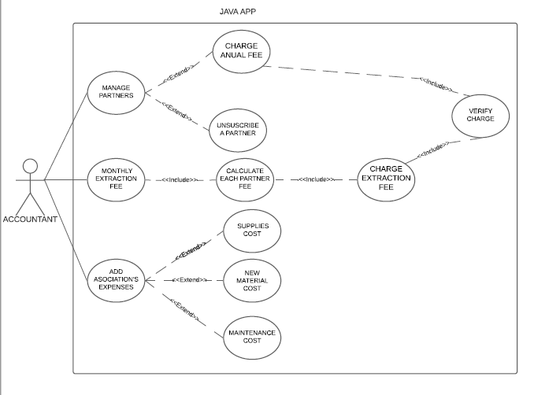

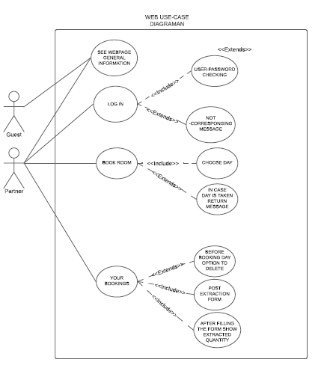

B) Activity diagrams

WEB

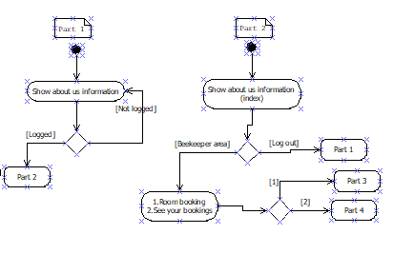

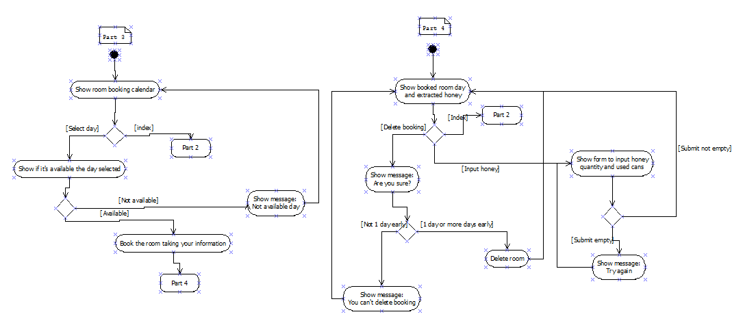

JAVA

C) Class diagram

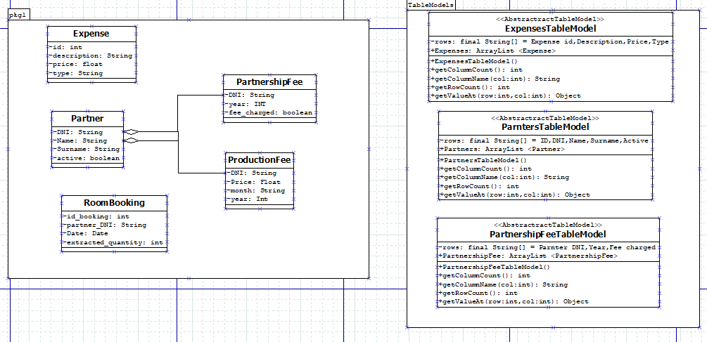

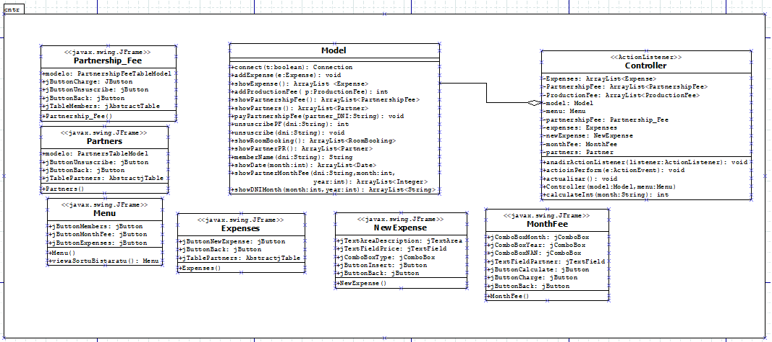

1. SOFTWARE APPLICATION, IMPLEMENTATION AND INSTALLATION

In order to use the java application, we strongly recommend this computer’s features:

* RAM: 4GB.
* Operate system: WINDOWS 10.
* Internet connection.
* JDK 15 application installed.

This kind of computer will also be able to connect to the web. Moreover, the computers which will connect to the web page will need this applications installed:

* Any kind of internet browser.
* Internet connection.

1. USERS GUIDE

# A) WEB

Depending on the fact that if the user is a member or not, there will be or not extra options. Firstly, once you entered into the web, the index will be shown. This index contains the information about the organization.

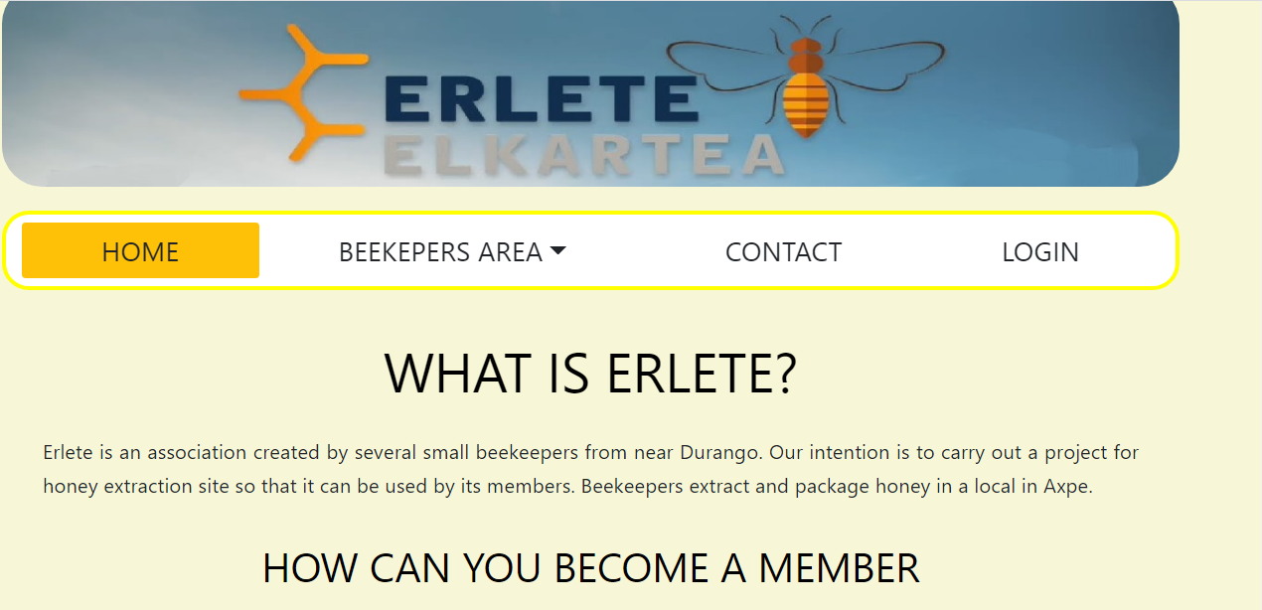

As the web shows, there is a navigation bar in which there are 4 different options: HOME, BEEKEPERS AREA, CONTACT and LOGIN. HOME, CONTACT and LOGIN are accessible to those users that are not currently members, whereas BEEKEPERS AREA is an exclusive option for organization members. Secondly, CONTACT option shows the contact information and where the place is. What is more, in case you want to send a message, there is also an option to send it.

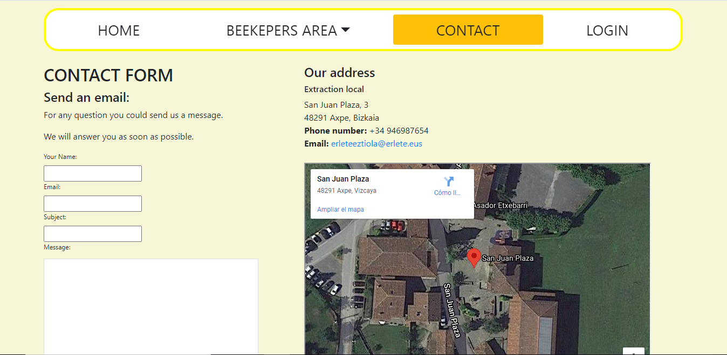

Thirdly, as we type before, although the login is shown to every user, members are only the ones who can login due to the fact that they have the credentials needed. To login, you only have to enter the email and password.

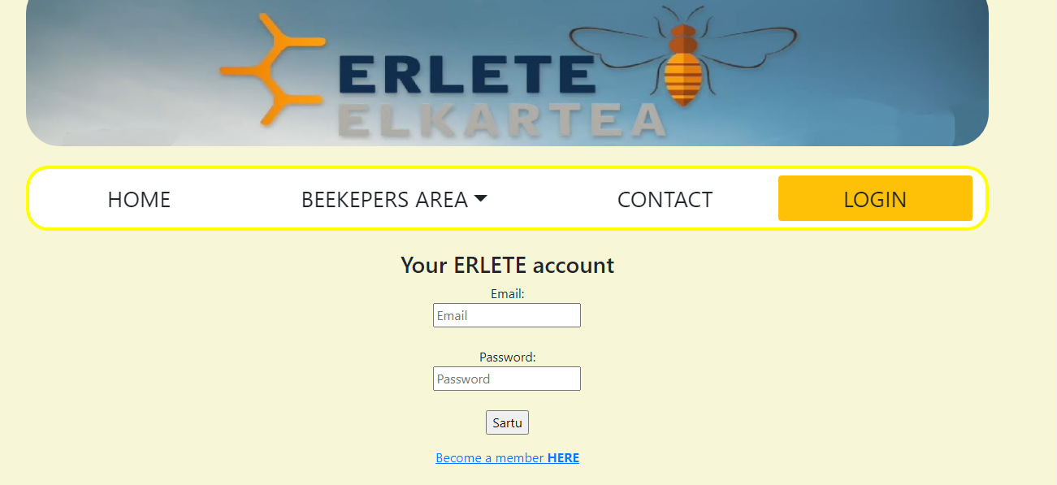

After that, there is a register inside the login page for those users who may want to become member of the organization. However, if someone wants to become member, he or she must complete the form.

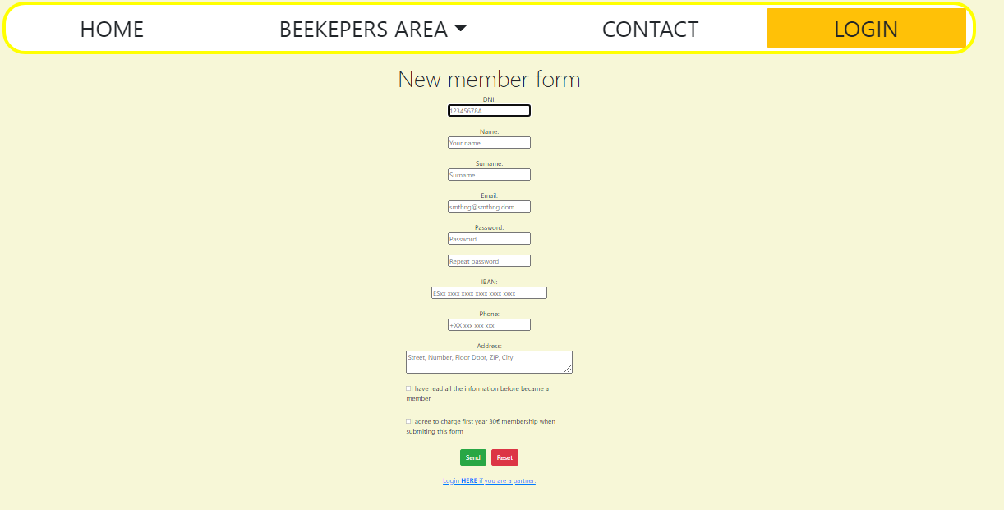

After any member have login, the beekeepers area will activated. In this area, member could book a room in order to extract some honey. Moreover, depending on what the member wants to do, there are two options: Room booking and your bookings. On the one hand, the room booking shows the room and can availability. This will be useful if any member wants to extract honey. To book the room, you only have to click on the day.

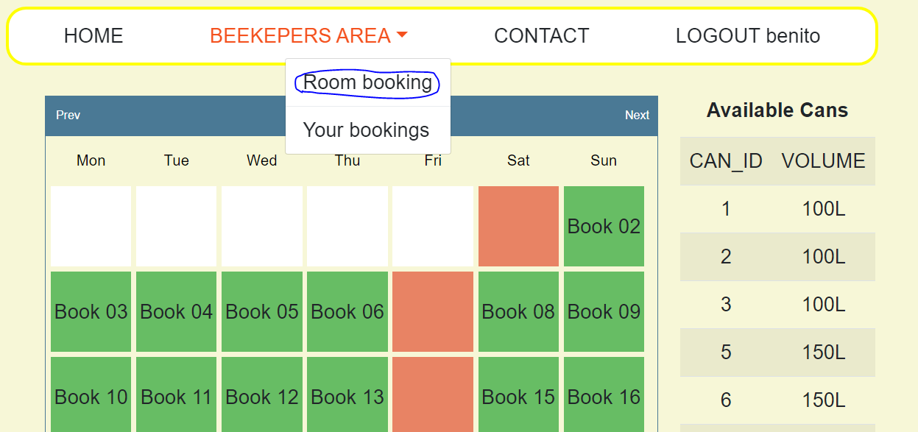

Once you have booked the room, this booking will appeared in your bookings section. Here, there are some different options depending on the day of the boking: Delete (this one is to cancel the booking), Form (this one is to complete the booking and to select the cans used) and Complete.

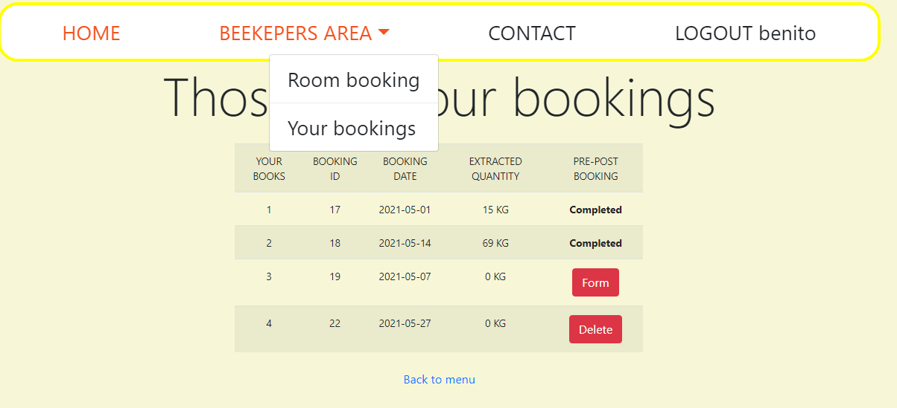

If you want to cancel a booking, before it get cancelled, an alert will appeared.

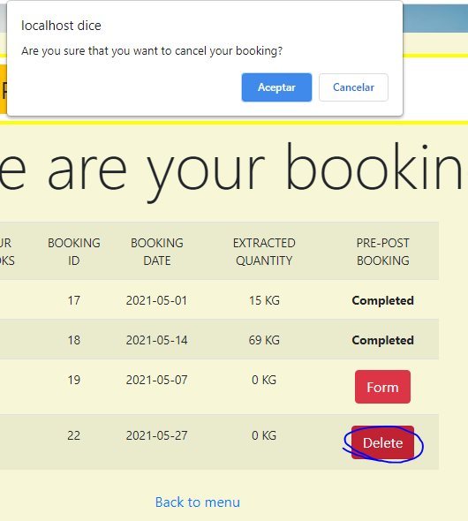

If you have extracted the honey, you have to select the option Form. Here you have to insert the extracted quantity and the can used. To select the can used, you have to select the button Used.

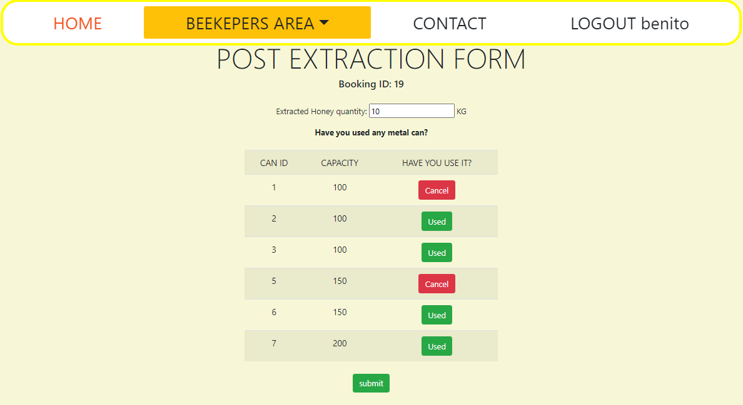

If you want to cancel the can used, it will show an alert as well.

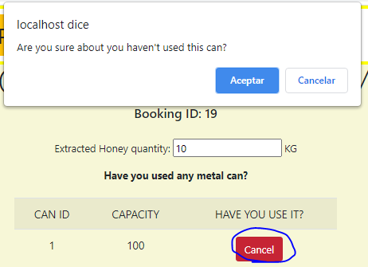

Last but not least, once you have entered all the information, you have to click on submit. As a result, a ticket will appeared.

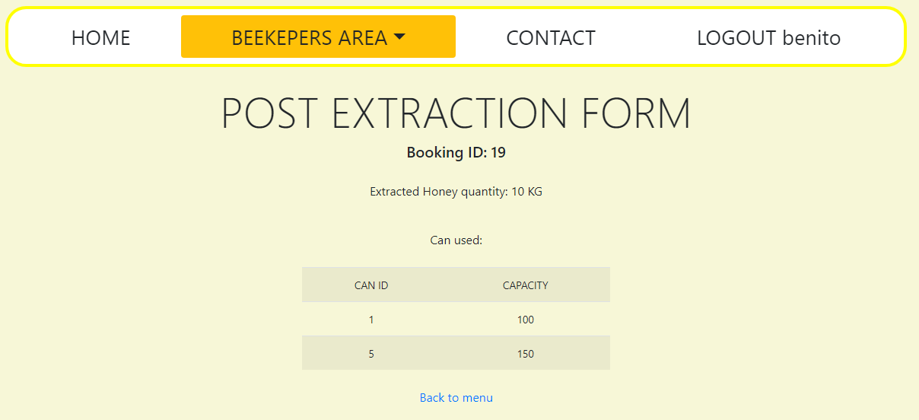

# B) java

The Java application part it will only be used by the accountant where he will be able to see all the movements and edit partnerships.

When the accountant enters to the application he will find a menu with three different functionalities.

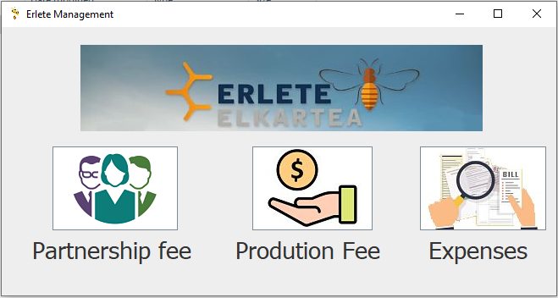

1. The first button (partnership fee) will open another jFrame where will appear a jTable with the partner DNI, year and if their fee is charged or not and three buttons which let the accountant to charge the fee, unsubscribe a partner or returning back to the menu.

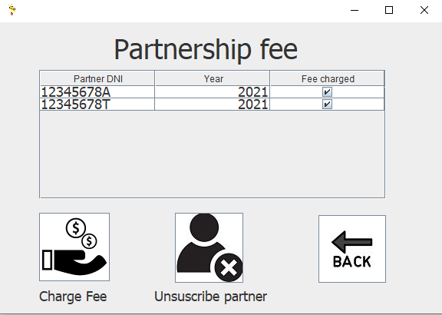

The “Charge Fee” button will charge the fee of the subscription of the current year and the “Fee charged” field will appear selected.

The “Unsuscribe partner” will open another jFrame where will appear all the partners, with their ID, DNI, name, surname and active field which will say if this partner still subscribed or not and a button to unsubscribe a partner.



The unsubscribe button will let the accountant to unsubscribe a partner and will delete that partner from the partners table. For that first of all the accountant will have to select the partner with the mouse and then will have to click the “Unsubscribe partner” button and a confirmation window will appear to confirm the unsuscription.



The back button will return you to the previous jFrame.

1. The second button (Production fee) will open a jFrame where the accountant will be able to calculate and charge the production fee of a determinate month and year.

In that jFrame the accountant will be able to select the month year and the partner DNI’s that coincide with the month and year selected. When he select the partner DNI, his name and surname will appear automatically in the partner case.

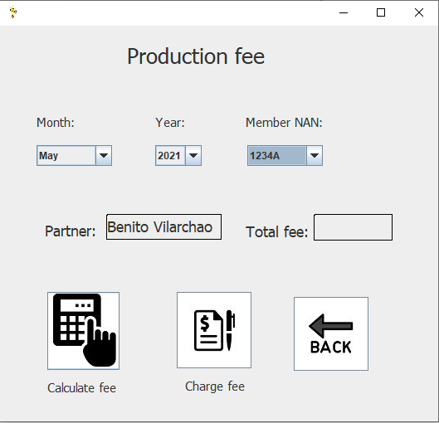

Once the partner info appeared the accountant will be able to calculate the fee and to charge it.

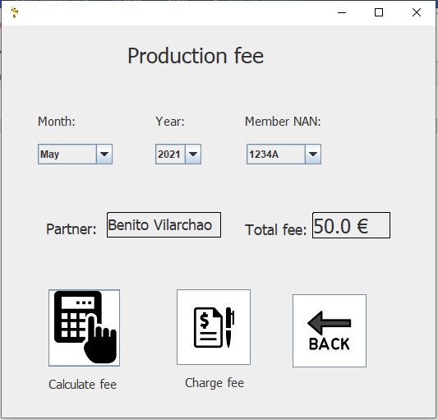

To charge the fee the accountant must calculate the fee before charge it otherwise a warning will come out.